“For my project, I built a complete DevSecOps pipeline around a microservices e-commerce application.
The application itself is made of many independent Spring Boot microservices, and my objective was not only to deploy them, but to create a full production-grade cloud environment using AWS, Terraform, Kubernetes, CI/CD, GitOps, and security tools.
I began by containerizing each microservice, provisioning a full AWS infrastructure using Terraform (including VPC, EKS cluster, node groups, and ECR), and deploying everything into Kubernetes using manifests, Ingress, and a custom domain.
I then added security at every stage using Trivy, OWASP Dependency-Check, Checkov, CodeQL, and ECR scanning — building a complete DevSecOps pipeline.
Finally, I implemented GitOps with ArgoCD so that each change in Git automatically updates the application in the cluster.
The result is a fully automated, secure, scalable e-commerce platform that follows modern industry DevSecOps standards.

⭐ 2. NARRATIVE EXPLANATION (FOR FULL PRESENTATION)
(This is the “story” — follow this flow during your restitution)
Step 1 — Understanding the Application
The system is a microservices-based e-commerce application.
Each service has a single responsibility — for example:
- Catalog Service
- Cart Service
- Order Service
- Payment Service
- User Service
- Notification Service
etc.
They communicate internally via REST APIs, using Kubernetes Service DNS names.

Step 2 — Local Development (Docker Compose)
Before touching the cloud, I ran the entire system locally using Docker Compose.
This allowed me to verify:
- Each microservice works
- Inter-service communication works
- Images can be built correctly
- The application behaves as expected
This forms the baseline before cloud deployment.

Step 3 — Infrastructure as Code (Terraform + AWS)
Instead of manually configuring AWS, I wrote Terraform code that automatically builds:
- A complete VPC
- Public + private subnets
- Route tables and gateways
- An EKS Kubernetes cluster
- Worker nodes (EC2 Node Groups)
- ECR repositories (with scanning)
- IAM roles and permissions
This ensures:
- Reproducible environments
- Version-controlled infrastructure
- Easy teardown + rebuild
- Professional DevOps standards

Step 4 — Deploying Microservices to Kubernetes
I built Docker images for each microservice and pushed them to ECR.
In Kubernetes, I created:
- Deployments → run the pods
- Services → stable internal DNS
- Ingress → expose HTTP routes
- Storage → persistent volumes for needed components
- ConfigMaps / Secrets → application config
Then I installed:
- AWS Load Balancer Controller
- Ingress configuration
- Custom domain with Route53
This made the platform accessible through a clean domain (ex: shop.mydomain.com).

Step 5 — DevSecOps Security Integration
Security was integrated into the CI/CD pipeline:
🔹 Trivy
Scans Docker images and blocks vulnerable builds.
🔹 OWASP Dependency-Check
Scans Maven dependencies for CVEs.
🔹 Checkov
Scans Terraform for insecure infrastructure configurations.
🔹 CodeQL
Performs SAST (Static Application Security Testing) on the Java code.
🔹 ECR Built-In Scanning
Scans pushed images automatically.
This enforces security by design at every stage — code, dependencies, containers, infrastructure.

Step 6 — GitOps with ArgoCD
Instead of manually applying Kubernetes YAML:
- ArgoCD watches the Git repository
- When manifests change, ArgoCD syncs automatically
- Cluster becomes self-healing
- Git becomes the single source of truth
This implements modern, declarative cloud-native deployment.

Step 7 — CI/CD Pipeline (GitHub Actions → ArgoCD)
The final automated workflow:
- Developer pushes code
- GitHub Actions runs:
  - Build
  - Test
  - Dependency scanning
  - Image scanning
  - Push to ECR
  - Update manifest repo
- ArgoCD detects manifest change
- ArgoCD deploys the new version
- EKS updates the pods seamlessly (rolling updates)
This creates a full continuous delivery pipeline.

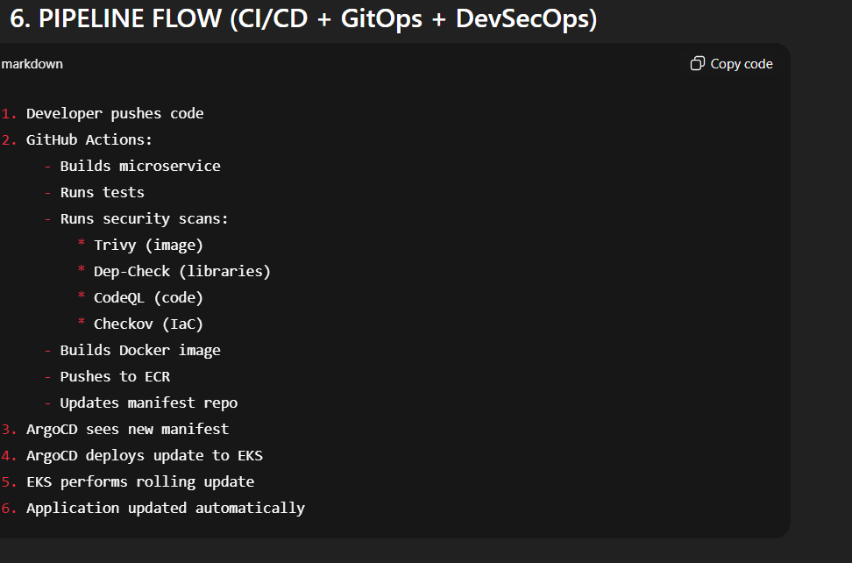

1. Basic Questions (the ones they ALWAYS ask)
Q1 — Where are you deploying your application?
A:
I am deploying my microservices application on Amazon EKS (Elastic Kubernetes Service) in the AWS cloud.
The Docker images are stored in Amazon ECR (Elastic Container Registry), not Nexus or Docker Hub.
Kubernetes pulls images from ECR and runs them inside pods in the EKS cluster.

Q2 — Why did you choose AWS instead of another cloud provider?
A:
AWS offers:
- A fully managed Kubernetes service (EKS)
- Powerful DevOps tools (ECR, IAM, Route53, ALB)
- Strong integration with Terraform
- High reliability and scalability
Also, most companies use AWS, so building this project prepares me for real industry environments.

Q3 — Why Kubernetes? Why not Docker Compose or EC2 only?
A:
Because Kubernetes is the standard for microservices orchestration.
It provides:
- Automatic scaling
- Rolling updates
- Self-healing
- Service discovery
- Separation of concerns
- Cloud-native resilience
Docker Compose is only for local development, not production.

Q4 — Why Terraform?
A:
Terraform allows me to:
- Automate all infrastructure creation
- Keep it version-controlled
- Reproduce environments easily
- Avoid manual error-prone operations
- Destroy and rebuild the entire cloud architecture instantly
It is the DevOps industry standard for Infrastructure-as-Code.

Q5 — Why not deploy directly from your local machine?
A:
Manual deployment is not:
- Scalable
- Secure
- Reliable
Instead, I use CI/CD pipelines + GitOps so everything is automated and reproducible.

🔵 2. Architecture and Microservices Questions
Q6 — How do the microservices communicate?
A:
Inside Kubernetes, microservices communicate via Kubernetes Services, which provide a stable DNS name.
Example:
http://catalog-service:8080
Kubernetes handles service discovery internally.

Q7 — Where is the database? Is it shared?
A:
In the course demo, microservices use simple storage mechanisms because the focus is DevOps, not business logic.
In a real project, each microservice would have its own database, often using:
- AWS RDS
- DynamoDB
- MongoDB
The architecture is designed to support independent databases, following microservice best practices.

Q8 — How does the external user reach your application?
A:
User → AWS Application Load Balancer → Kubernetes Ingress → Frontend Service → Backend Services
AWS Load Balancer Controller automatically creates the ALB for the Ingress.

Q9 — Why use a custom domain and Route53?
A:
To provide a professional, user-friendly URL and enable HTTPS routing.
Route53 integrates perfectly with AWS Load Balancers and Kubernetes Ingress.

🔵 3. CI/CD and GitOps Questions
Q10 — Why ArgoCD?
A:
ArgoCD implements GitOps, where Git is the single source of truth.
It provides:
- Automatic deployments
- Rollbacks
- Continuous synchronization
- Clear visualization of cluster state
This is more modern and reliable than manually running kubectl.

Q11 — What does your GitHub Actions pipeline do?
A:
For each microservice, it performs:
- Build
- Tests
- Security scans:
  - Trivy
  - Dependency-Check
  - CodeQL
  - Checkov (for Terraform in infra repo)
- Build Docker image
- Push to ECR
- Update Kubernetes manifests
- Trigger deployment via ArgoCD
This is a complete DevSecOps pipeline.

Q12 — What happens if a vulnerability is found?
A:
The pipeline fails, and the image is not pushed or deployed.
This prevents insecure code or containers from reaching production.

🔵 4. Security / DevSecOps Questions
Q13 — Why Trivy?
A:
It’s the easiest and most widely used tool for scanning container images.
It identifies OS vulnerabilities and library vulnerabilities.

Q14 — What is CodeQL used for?
A:
CodeQL performs static code analysis and detects:
- SQL injection risks
- Unsafe deserialization
- Hardcoded secrets
- Dangerous patterns in code
It is integrated directly with GitHub.

Q15 — What does Checkov check?
A:
Checkov scans Terraform code for misconfigurations like:
- Publicly exposed resources
- Overly permissive IAM policies
- Open security groups
- Misconfigured VPC or subnets
This ensures cloud infrastructure follows best practices.

Q16 — What about secrets? How do you handle them?
A:
Secrets can be stored:
- In Kubernetes Secrets for simplicity
- Or securely in AWS Secrets Manager (recommended in production)
No secrets are hardcoded or stored in GitHub.

🔵 5. Cloud / Kubernetes Questions
Q17 — What happens if one pod crashes?
A:
Kubernetes automatically restarts it, thanks to the ReplicaSet managed by the Deployment.

Q18 — What happens if traffic increases?
A:
Kubernetes scales pods horizontally.
Node groups can also auto-scale using AWS autoscaling.

Q19 — What is the role of IAM in your project?
A:
IAM manages:
- EKS cluster permissions
- Node instance permissions
- Access to ECR
- Access to Route53
- Security boundaries for cloud resources

Q20 — How do you destroy everything to save cost?
A:
Everything is created by Terraform, so I use:
terraform destroy
This deletes the entire infrastructure instantly.

🔵 6. Difficult Questions (Tricky ones the jury loves)
Q21 — Why did you choose microservices instead of monolithic architecture?
A:
Microservices allow:
- Independent scaling
- Independent deployments
- Better fault isolation
- Faster development cycles
- Team autonomy
It also aligns perfectly with Kubernetes and DevOps practices.

Q22 — What challenges did you face and how did you solve them?
You can say:
- Managing NAT gateway costs → solved by reducing them from 3 to 1
- Terraform destroy errors → caused by load balancers and SG dependencies; solved by cleaning AWS resources
- Kubernetes Ingress configuration → learned how AWS Load Balancer Controller integrates
- Balancing DevOps + DevSecOps complexity → started with essential tools (Trivy, OWASP, Checkov, CodeQL)

Q23 — What value does GitOps add compared to traditional CI/CD?
A:
GitOps makes the cluster always match the state of Git.
It provides:
- Self-healing deployments
- Full auditability
- Predictable rollbacks
- Less human error
ArgoCD ensures deployments are always aligned with Git.

📌 Project Summary — DevSecOps E-Commerce Platform
Architecture
- Microservices-based Spring Boot application
- Dockerized services
- Kubernetes orchestrated on Amazon EKS
- Ingress + Route53 for custom domain routing
- ECR for container registry
Infrastructure (IaC)
- Terraform to automate:
  - VPC
  - Subnets
  - EKS cluster
  - Node groups
  - IAM roles
  - ECR repos
- S3 + DynamoDB for Terraform backend
DevSecOps Pipeline
- Trivy → container vulnerability scanning
- OWASP Dependency-Check → dependency scanning
- CodeQL → static code analysis (SAST)
- Checkov → IaC security
- ECR scanning → image scanning on push
- GitHub Actions → CI automation
GitOps Deployment
- ArgoCD for continuous delivery
- Automatic sync from Git → EKS
- Rolling updates and rollback mechanisms
Final Result
A fully automated, secure, scalable, cloud-native platform that demonstrates modern DevSecOps, Cloud, Kubernetes, and IaC best practices.

